LAB-1
C# FIRST PROGRAM
using System;

class Program
{
static void Main()
{
Console.WriteLine("Hello World!");
}
}
2-CODE
using System;

class Program
{
static void Main()
{
Console.Write("Enter your name: ");
string name = Console.ReadLine();

Console.WriteLine("Hello " + name);
}
}
3-CODE
using System;

class Program
{
static void Main()
{
int age = 20;
float height = 5.5f;
double marks = 85.75;
char grade = 'A';
string name = "Imad";
bool pass = true;

Console.WriteLine("Name: " + name);
Console.WriteLine("Age: " + age);
Console.WriteLine("Height: " + height);
Console.WriteLine("Marks: " + marks);
Console.WriteLine("Grade: " + grade);
Console.WriteLine("Pass: " + pass);
}
}
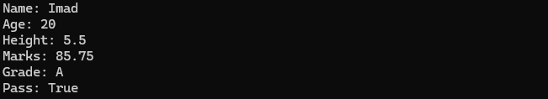
4-CODE
using System;

class Program
{
static void Main()
{
int num1 = 10;
int num2 = 20;

int sum = num1 + num2;

Console.WriteLine("Sum = " + sum);
}
}
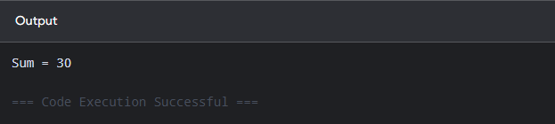
5-CODE
using System;

class Program
{
static void Main()
{
int num1 = 20;
int num2 = 10;

int add = num1 + num2;
int min = num1 - num2;
int mul = num1 * num2;
int div = num1 / num2;

Console.WriteLine("Addition = " + add);
Console.WriteLine("Subtraction = " + min);
Console.WriteLine("Multiplication = " + mul);
Console.WriteLine("Division = " + div);
}
}
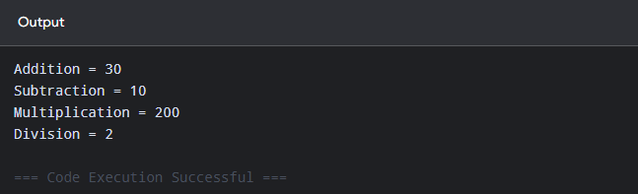
6-CODE
using System;

class Program
{
static void Main()
{
Console.Write("Enter first number: ");
int num1 = Convert.ToInt32(Console.ReadLine());

Console.Write("Enter second number: ");
int num2 = Convert.ToInt32(Console.ReadLine());

int add = num1 + num2;
int min = num1 - num2;
int mul = num1 * num2;
int div = num1 / num2;

Console.WriteLine("Addition = " + add);
Console.WriteLine("Subtraction = " + min);
Console.WriteLine("Multiplication = " + mul);
Console.WriteLine("Division = " + div);
}
}
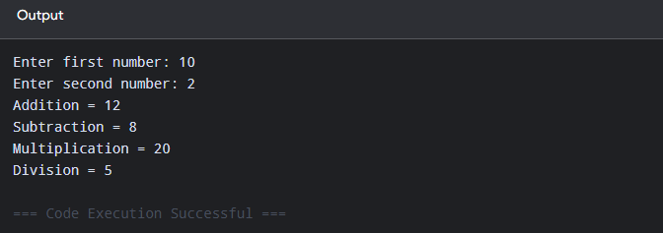

Website
- Website = Information
- Usually read-only
- A portfolio is usually a website.
Web Application
- Interaction + Tasks
- Usually interactive
- Student Portal → login, register courses, check grades
For loop
using System;

class Program
{
static void Main()
{
for (int i = 1; i <= 5; i++)
{
Console.WriteLine(i);
}
}
}
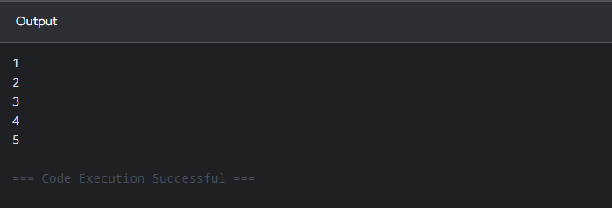
while Loop
using System;

class Program
{
static void Main()
{
int i = 1;

while (i <= 5)
{
Console.WriteLine(i);
i++;
}
}
}
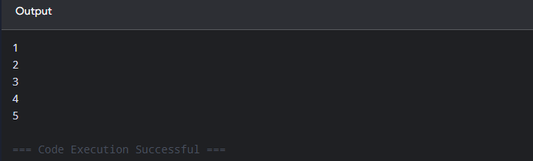
do-while
using System;

class Program
{
static void Main()
{
int i = 1;

do
{
Console.WriteLine(i);
i++;
}
while (i <= 5);
}
}
if-else
using System;

class Program
{
static void Main()
{
Console.Write("Enter a number: ");
int num = Convert.ToInt32(Console.ReadLine());

if (num >= 0)
{
Console.WriteLine("Positive");
}
else
{
Console.WriteLine("Negative");
}
}
}
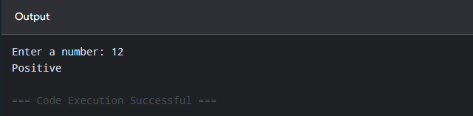
switch

using System;

class Program
{
static void Main()
{
Console.Write("Enter a number (1-3): ");
int num = Convert.ToInt32(Console.ReadLine());

switch (num)
{
case 1:
Console.WriteLine("One");
break;

case 2:
Console.WriteLine("Two");
break;

case 3:
Console.WriteLine("Three");
break;

default:
Console.WriteLine("Invalid number");
break;
}
}
}
